Tugs Daycare & Preschool
Registration/Release Forms

Child’s Last Name _________________________First Name_____________________________
Date of Birth______________________________Nickname_____________________________
Address_______________________________________________________________________
Phone___________________________________Gender______________Age______________
Father’s Name____________________________Address_______________________________
Phone___________________________________Cell___________________________________
Mother’s Name____________________________Address______________________________
Phone___________________________________Cell___________________________________

Child lives with (circle one) Mother Father Both
Mother’s Work Father’s Work

Employer_________________________ Employer__________________________
Work Phone_______________________ Work Phone________________________

Child’s Doctor____________________________ Address____________________________

Doctor’s Phone___________________________Insurance Company____________________________

Child’s Dentist____________________________Address____________________________

Dentist’s Phone___________________________Insurance Company____________________________

Emergency Contacts:
Name___________________________________Address_____________________________
Relationship______________________________Phone______________________________

Name___________________________________Address_____________________________
Relationship______________________________Phone______________________________

Persons Authorized to take your children from the center:
____________________ ____________________ ____________________

Persons not authorized to take your child from the center: (court ordered)
_____________________________________________________________________

Name of last child care provider:__________________________________________

List names and ages of siblings: Name Age
_______________ __________
_______________ __________
_______________ __________
_______________ __________

I, ____________________and____________________have received and read the regulations set up by TUG’S Daycare & Preschool and agree to comply with all the rules and responsibilities therein stated.

Start date:____________________

Weekly schedule: Monday_______________________
Tuesday_______________________
Wednesday____________________
Thursday______________________
Friday_________________________

Any variation of this schedule must be presented to the TUG’S staff in writing, and approved in order to maintain consistent and adequate staffing.

A $35.00 charge will be made on checks returned due to insufficient funds. After two such checks returned, cash payments will be necessary. TUG’S hours of operation are 6:00 a.m. to 6:00 p.m. Monday – Friday. A $20.00 late fee will be charged to your account if your child/children are picked up after our closing time. Legal action will be taken on all accounts over 60 days past due, and continued attendance will be denied.

TUG’S requires an attendance minimum of 12 hours per week, per school-age child; a 40 hour per week minimum is charged per family of children 2-years-old and younger, a 35 hour per week minimum is charged per family of children ages 3 through 5-years-old. This guarantee will be paid every week regardless of attendance.

TUG’S offers families a 2 week vacation allowance per year with no minimum payment required. A two week notice of vacations, in writing, with dates indicated, must be turned into the office in order to ensure proper billing procedures.

Parents will be required to register and/or update your registration annually in late summer before the new school year begins. A $35.00 registration fee per child will be charged upon entering our program. A $25.00/child maintenance fee will be charged every September.

TUG’S Daycare & Preschool reserves the right to discharge a child if the staff and director agree that continued care of a particular child might be detrimental to the child or any part of the Daycare program.

A 2 week notice in writing is required for discontinuing service.

TUG’S is funded 100% by parent fees. It is important that you pay on time. We cannot extend credit to any family enrolled at TUG’S.

I have read this document and fully understand my obligation to pay my account.

Parent Signature____________________ Date____________________
Parent Signature____________________ Date____________________

TUG’S Daycare & Preschool Director____________________ Date____________________

Permission and Emergency Authorization Releases

Child’s name____________________

By signing my name below, I agree to the following:

Program I agree to abide by the terms and conditions of Tug’s Daycare and Preschool Program. I have received and read a copy of the terms and conditions, and the Tug’s handbook. I agree that my child may use all the play equipment and participate in all the activities at Tug’s.
__________________________

Medical In case of an emergency involving the above named child, I authorized the Tug’s program to use the Mercy Medical Center-North Iowa for emergency medical treatment, if I or the child’s doctor could not be reached. I authorize Tug’s to call 911 to seek emergency care if deemed necessary, and agree that I would be responsible for the charges.
_________________________

Fieldtrips I give permission for the above named child to leave the center (Tug’s) for walks and to participate in field trips sponsored by Tug’s. Planned trips will be posted. Children will always be accompanied by Tug’s staff members, and transported in vehicles with car seats and adequate ratios met. No children will be allowed to be transported in the front seat of any vehicle.
___________________________

Publicity I give my consent to have picture taken of my child(ren) by the news media and or the staff at Tug’s. These may be used in newspapers, displays, bulletin boards or other educational publications.
_________________________

My signature below shows that I agree to assume responsibility for any and all expenses that may be incurred under the circumstances outlined above:

Signature_____________________________________________Date:____________________

Return this form with $35 non-refundable registration fee to the Tug’s office.

PARENTS COMPLETE THIS PAGE Child’s Name:
Parents: Tell us about your child's health. Place an X in the box if the sentence ap- plies to your child. Check all that apply to your child. This will help your doctor plan your child’s physical exam.
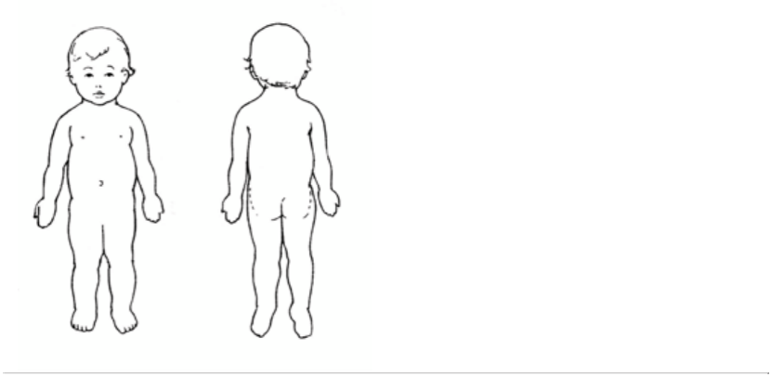
Growth
I am concerned about my child's growth.

Appetite
I am concerned about my child's eating /
feeding habits or appetite.

Rest -
I am concerned about the amount of sleep my child needs.

Illness/Surgery/Injury - My child
had a serious illness, injury, or surgery.
Please describe.

Physical Activity - My child
must restrict physical activity.
Please describe.
Body Health - My child has problems with

Skin, birthmarks, Mongolian spots, hair, fin- gernails or toenails.
Map and describe color/shape of skin markings birthmarks, scars, moles

Eyes \ vision, glasses
Ears \ hearing, hearing aides or device, ear- aches, tubes in ears
Nose problems, nosebleeds, runny nose Mouth, teething, gums, tongue, sores in mouth or on lips, mouth-breathing, snoring Frequent sore throats or tonsillitis
Breathing problems, asthma, cough, croup
Heart, heart murmur
Stomach aches, upset stomach, colic, spitting up
Using toilet, toilet training, urinating
Bones, muscles, movement, pain with mov-
Development and Learning
I am concerned about my child’s behavior, development, or learning.
ing

Mobility, uses assistive equipment
Nervous system, headaches, seizures, or
Please describe:

Medication - My child takes medication. List the name, time medication taken, and the reason medication prescribed.
nervous habits (like twitches)
Needs special equipment. Please describe:

Allergies-My child has allergies (medicine, food, dust, mold, pollen, insects, animals, etc.).

Please describe:

Parent questions or comments for the health care provider
Iowa Child Care Infant, Toddler, Preschool Age – Child Health Exam Form

HEALTH PROFESSIONAL COMPLETE THIS PAGE1
Child’s Name: Birthdate: Age today:
Date of Exam:

Height/Length: Weight:
Head Circumference-for children age 2 yr and under:

Blood Pressure-start @ age 3 yr: Hgb or Hct-anytime between 6-9 mo: Blood Lead Level-start @ 12 mo:
Sensory Screening:
Allergies

Environmental:
Medication:
Food:
Insects:
Other:

Immunization: May attach a copy of Iowa Department of
Public Health Immunization Certificate

DtaP/DTP/Td MMR

Hepatitis B Pneumococcal
HIB Varicella Polio Other Influenza
Vision: Right eye
Left eye
TB testing (only for high-risk child)
Hearing: Right ear
Left ear

Medication: Health professional authorizes the child may
Tympanometry (may attach results) Developmental Screening2 : Developmental screening results: Autism screening results: Psychosocial/behavioral results
Developmental Referral Made Today: □Yes □No Exam Results: (n = normal limits) otherwise describe HEENT
Oral/Teeth

Oral Health/Dental Referral Made Today: Yes No

Heart Lungs Stomach/Abdomen Genitalia
Extremities, Joints, Muscles, Spine

Skin, Lymph Nodes

Neurological

Space is available on back page for detailed
comments or instructions pertaining to enrollment at child care or preschool.

1 Iowa Child Care Regulations require an admission physical exam report within the previous year. Annually thereafter, a statement of health con- dition signed by an approved health care provider. The American Acad- emy of Pediatrics has recommendations for frequency of childhood pre- ventative pediatric health care (RE9939, March 2000) www.aap.org
2 Developmental screening procedures were expanded to include aut-
ism, developmental surveillance, and psychosocial/behavioral screening
July 2009 by the Iowa EPSDT Medicaid program. Toll-free 800-383-
3826.receive the following medications while at child care or pre- school: (include over-the-counter and prescribed)

Medication Name Dosage
Cough medication
Diaper crème:
Fever or Pain reliever: Sunscreen:
Other

Other Medication should be listed with written instructions for use in child care.

Referrals made:
Referred to hawk-i today 1-800-257-8563
Other:

Health Provider Assessment Statement:

The child may participate in developmentally ap- propriate child care/preschool with NO health-related restrictions.

The child may participate in developmentally ap- propriate child care/preschool with the following re- strictions:

Signature
May use stamp
Circle the Provider Credential Type: MD DO PA ARNP
Address: Telephone:

